FPT ACADMY INTERNATION
FPT-APTECH
--o0o--



Project Report

Medical Store Billing

Students’ name (code on eProject Guide):
- Nguyen Van Chien (1882) (Leader)
- Tran Van Hien (1024)

Leader’s email: chien.nv235@gmail.com
Fanculty: Dao Trong Duy

HaNoi 9/2009

HANOI 08-2009

Table of contents

Problem definition 3
Customer Requirement Specification (CRS) 6
Requirements Analysis 7
Data Flow Diagram 15
Flow Chart 21
Entity Relationship Diagram 25

Name of the Students  (code on eProject Guide) | Nguyen Van Chien(1882) (Leader)  Tran Van Hien( 1024)
Name of the Center | FPT Aptech
Name of the Project | Medical Store Billing System
Project Start Date/ End Date | 22-Aug-2009/ 22-Sep-2009
Form | Problem definition
Form code | Form No.1/PD/Ver 1.0

Now there are many Medical Stores around the world, in a country … Each store has many business activities: buying goods from distributors; selling medicines to dealers or customers; managing store; processing orders and paying bills … Each of the Medical Stores system found there way different organizations.
The Medical Stores in each country is organized and how different activities, depending on the characteristics of each country .

RS Medical Agencies is a General Medical Store, which buys and sells the medicines as per the requirement of the customer. It has so many dealer ships from which the medicines are purchased and also some of the medicines it gets directly from the company and some of them from the wholesale retail shops. For the past few months they are facing difficulties in the current system for tracking down the details of the available and that of the sold due to the increased consumption of the medicines.

So they had approached you to study the situation and resolve their difficulties in maintaining the records of the sold ones and that of the available and also to track down the details of the Payments done to the distributors, received from the customers, etc… and also to track down the information of the quantity of the stock available and that of the purchasable.

This application will solve all of them: holding the complete information about the drugs, dealers, and wholesale retailers in a modular form so as to make a convenient approach to track all the records maintaining the list of the order requests so as to deliver in time to the corresponding customer.

- Types of user:
  - Manager
  - Accountant
  - Seller

- Name of application: e- Medical store billing.
- Main function of the application: managing business activities of a medical store.

Name of the Students  (code on eProject Guide) | Nguyen Van Chien(1882)(Leader)  Tran Van Hien ( 1024)
Name of the Center | FPT Aptech
Name of the Project | Medical Store Billing System
Project Start Date/End Date | 22-Aug-2009/ 22-Sep-2009
Form | Customer Requirement Specification (CRS)
Form code | Form No.2/CRS/Ver 1.0

- Functions of the application:
  - Help user to log in depends on their user type. Each user can change his/ her password. Depending on the type of manager that their powers will be different.
  - Create, insert, update, delete and seach - view guest
    - All users can use this module
  - Medicine management: create, insert, update, delete and seach - view goods
- Only manager can use this module.
- When there is a bill created, the application will update quantity automatically into database or manager will update normally by-hand
- Medicine management have the highest administrator
  - Create, delete, seach, view and edit orders
- Only seller and manager can use this module
- Users can choose guest from guest table
- After a order is created, it will be added into database and arranged with a condition. It’s easy to reference and create bill depends on order’s priority
  - Create, delete, seach, view and edit bills to import goods, bills to export (depends on order’s priority, avaiable goods …)
- Only accountant and manager can use this module
- User can choose a order to create a export bill or create a customized bill
- Beacause orders are arranged with some conditions so user can choose easily
- Depend on guest’s type, price of good will have a extra fund or not. If guest is customer, extra fund is “x%”. If guest is customer, extra fund is “y%”. Usually, y is less than x.
- System can show status of each bill created, how much money the guest will pay in the next time, has massage to alert bills became expired, … etc
  - Create, delete, seach, view and edit report when a customer, dealer pay bill (one times or many times depends on the expired time of that bill)
- Only accountant and manager can use this module
- After a session, there is a message to alert how much the guest must pay in the next time.
  - Manager (admin) have ability to create, delete an account and edit an account’s type. Beside it, he/ she has all ability of an other account. In other way, he can do everything.
  - When users delete, update a records, there is a alert to confirm that they are sure or not

- Hardware Requirements:
  - A minimum computer system can help you to access all tools in the course
  - 256Mb Ram or higher

- Software requirements: Java SE 5.0, NetBeans 5.5, MS SQL Server 2005

Name of the Students  (code on eProject Guide) | Nguyen Van Chien(1882)(Leader)  Tran Van Hien (1024)
Name of the Center | FPT Aptech
Name of the Project | Medical Store Billing System
Project Start Date/ End Date | 21-Mar-2009/ 19-Apr-2009
Form | Requirements Analysis
Form code | Form No.3 / RA / Ver 1.0

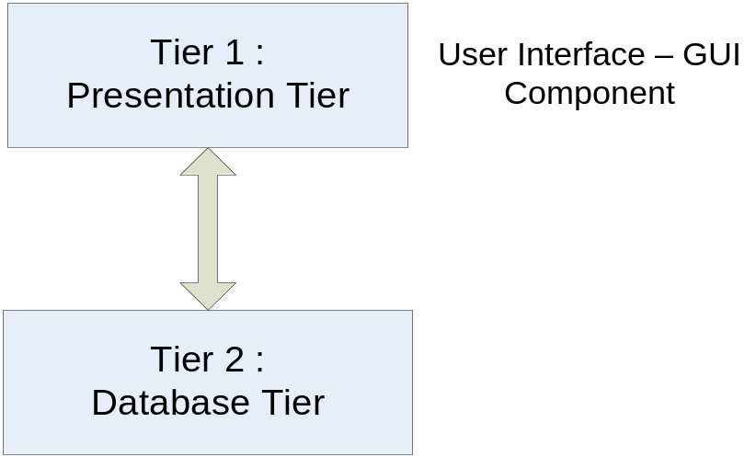

Two – tier architecture

Login
User type | Manager, accountant, seller
Description | A GUI helps user to log in the application
Activate | Fill all of fields and click “login” button
Pre-condition
Pos-process
Flow chart (step by step) | - Enter datainput (user code and password)  - Click “login” button  - If data is valid, there is a message to alert that log in successfully  - If data is invalid, there is a message to alert that user code or password was wrong
Exception
Special request

Main menu
User type | Manager, accountant, seller
Description | A GUI helps user to choose function
Activate | Choose and click buttons
Pre-condition
Pos-process
Flow chart (step by step) | Choose and click to buttons
Exception
Special request | User must login successfully

Medicine management
User type | Manager
Description | A GUI helps manager to manage drugs normally
Activate | Fill all of fields and click buttons
Pre-condition | User must be manager
Pos-process
Flow chart (step by step) | - Add drug:  - Click add button, a new form will appear  - Enter new data to fields  - Click save button to save data  - If data is invalid, there is a message to alert that the transaction stopped  - If data is valid, there is a message to alert that add successfully  - Delete drugs:  - Choose data rows and click delete button  - A alert will appear to confirm:  - If you choose “yes”, all data of drug will be deleted  - If you choose “no” or “cancel”, nothing will be done  - Update drug:  - Click update button, a new form will appear  - Edit fields in that form to update your drug  - Click save button to save data  - There is a message to confirm  - If you choose “yes”:  - If data is invalid, there is a message to alert that the transaction stopped  - If data is valid, there is a message to alert that add successfully  - If you choose “no” or “cancel”, nothing will be done  - Search:  - Click search button, a new form will appear  - Enter data into fields to search  - If there is a result, these informations will appear. You can use buttons to do something with these drugs  - If there is nothing, an alert will appear  - Clear store:  - Click clear button  - A message will be appear to confirm  - If you choose “yes”, all data will be deleted  - If you choose “no” or “cancel”, nothing will be done  - Back to main menu:  - Click back button, you will be brought to main menu
Exception
Special request | User must be manager

Order management
User type | Manager, seller
Description | A GUI helps user can enter Order from customer
Activate | Fill all of fields and click buttons
Pre-condition
Pos-process
Flow chart (step by step) | - Press “Select Guess” to choose a customer exited in Guess list or “New Guest” to enter new customer.  - Choose “Add” button to add some medicines into right table.  - A new window will be appeared.  - You choose a medicine from medicines list  - Enter quantity and measure of that medicine.  - Click “Ok” button to add that medicine into Medicines table.  - Choose “Edit” button to edit quantity, measure of a medicine.  - Choose “Remove” button to remove a medicine from right table.  - Press “Calculate” to calculate total money of all medicines.  - Press “Save” to save this Order or “Cancel” to exit this windows.
Exception
Special request | User must be manager, seller

Bill Managerment
User type | Manager, accountant
Description | A GUI helps user can enter Bill
Activate | Fill all of fields and click buttons
Pre-condition
Pos-process
Flow chart (step by step) | - Choose Bill type is Import or Export.  - If bill type is Import, press Select Order to choose a Order enterd, If bill type is Export, press New Bill.  - If press “New Bill”, a new window will be appear, you enter all information about that Manufactory.  - Press “Ok” button to accept and return New Bill windows, or “Cancel” to reject.  - Choose “Add” button to add some medicines into right table.  - A new window will be appeared.  - You choose a medicine from medicines list  - Enter quantity and measure of that medicine.  - Click “Ok” button to add that medicine into Medicines table.  - Choose “Edit” button to edit quantity, measure of a medicine.  - Choose “Remove” button to remove a medicine from right table.  - Press “Calculate” to calculate total money of all medicines.  - enter expired Date.  - Press “Save” to save this Bill or “Cancel” to exit this windows.
Exception
Special request | User must be manager, accountant

Pay management
User type | Manager, accountant
Description | A GUI helps user to manage bills
Activate | Fill all of fields and click buttons
Pre-condition | User must be manager or accountant
Pos-process
Flow chart (step by step) | Pay bill:  - Enter bill code or choose bill code from database by clicking select button  - Enter fund and date  - Click pay button to pay bill  - If done, there is a message to alert that pay successful and amount of fund will be payed in future  Manage report:  Only manager can use this function to delete, edit reports
Exception
Special request | User must be manager, accountant

User management
User type | Manager
Description | A GUI helps manager to manage users who log in the system and use functions
Activate | Fill all of fields and click buttons
Pre-condition | User must be manager
Pos-process
Flow chart (step by step) | - Add User:  - Click add button, a new form will appear  - Enter new data to fields  - Click save button to save data  - If data is invalid, there is a message to alert that the transaction stopped  - If data is valid, there is a message to alert that add successfully  - Delete User:  - Choose data rows and click delete button  - A alert will appear to confirm:  - If you choose “yes”, all data will be deleted  - If you choose “no” or “cancel”, nothing will be done  - Update User:  - Click update button, a new form will appear  - Edit fields in that form to update your drug  - Click save button to save data  - There is a message to confirm  - If you choose “yes”:  - If data is invalid, there is a message to alert that the transaction stopped  - If data is valid, there is a message to alert that add successfully  - If you choose “no” or “cancel”, nothing will be done  - Search:  - Click search button, a new form will appear  - Enter data into fields to search  - If there is a result, these informations will appear. You can use buttons to do something with these drugs  - If there is nothing, an alert will appear  - done  - Back to main menu:  - Click back button, you will be brought to main menu
Exception
Special request | User must be manager

Guest management
User type | All users
Description | A GUI helps user to guests
Activate | Fill all of fields and click buttons
Pre-condition | User must log in before
Pos-process
Flow chart (step by step) | - Add guest:  - Click add button, a new form will appear  - Enter new data to fields  - Click save button to save data  - If data is invalid, there is a message to alert that the transaction stopped  - If data is valid, there is a message to alert that add successfully  - Delete guest:  - Choose data rows and click delete button  - A alert will appear to confirm:  - If you choose “yes”, all data will be deleted  - If you choose “no” or “cancel”, nothing will be done  - Update guest:  - Click update button, a new form will appear  - Edit fields in that form to update your drug  - Click save button to save data  - There is a message to confirm  - If you choose “yes”:  - If data is invalid, there is a message to alert that the transaction stopped  - If data is valid, there is a message to alert that add successfully  - If you choose “no” or “cancel”, nothing will be done  - Search:  - Click search button, a new form will appear  - Enter data into fields to search  - If there is a result, these informations will appear. You can use buttons to do something with these drugs  - If there is nothing, an alert will appear  - done  - Back to main menu:  - Click back button, you will be brought to main menu
Exception
Special request | User must login

Special report
User type | Manager, accountant
Description | A GUI helps user to show and export reports
Activate | Choose a radio button. Click view report to show and export to save reports to html file
Pre-condition
Pos-process
Flow chart (step by step) | - Choose a radio button Click “login” button  - Click view report to show  - Click export to save reports to html file
Exception
Special request | User must login

Name of the Students  (code on eProject Guide) | Nguyen Van Chien (Leader)  Tran Van Hien
Name of the Center | FPT Aptech
Name of the Project | Medical Store Billing System
Project Start Date/ End Date | 22-Aug-2009/ 22-Sep-2009
Form | Data Flow Diagram
Form code | Form No.4/DFD/Ver 1.0

1. Hierarchy Function Diagram
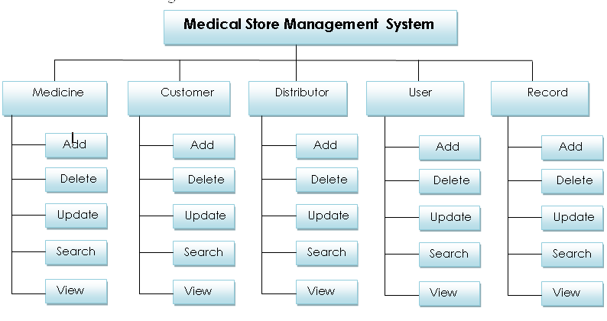

2. Context Diagram (DFD level 0)
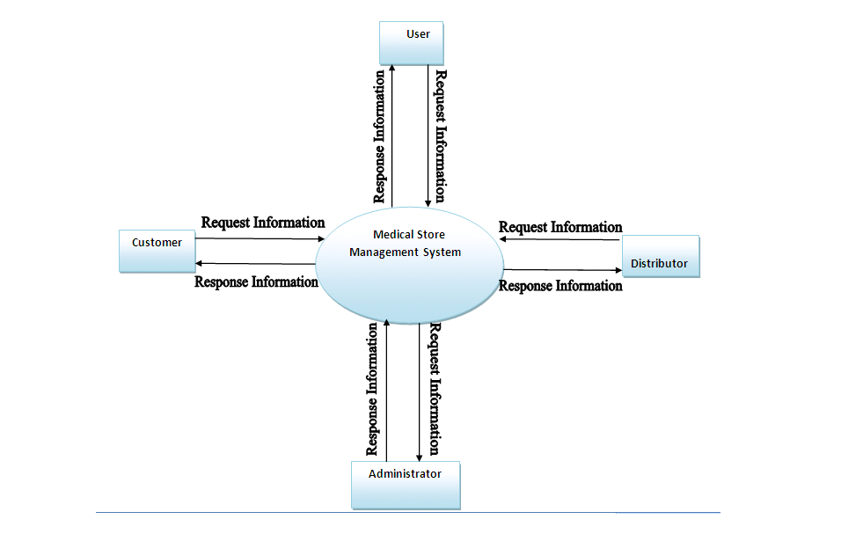

3. DFD Level 1
3.1. Medicine Management
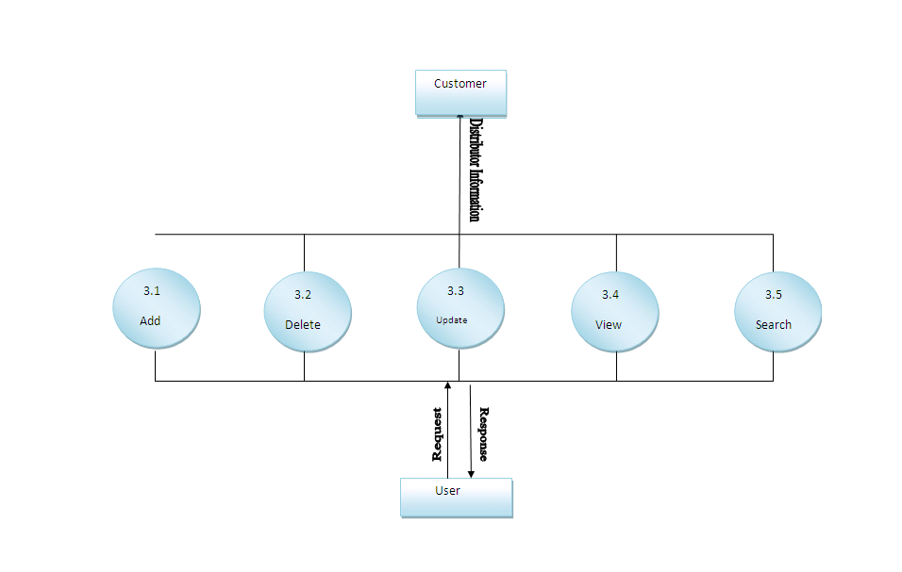

3.2. Distributor Management
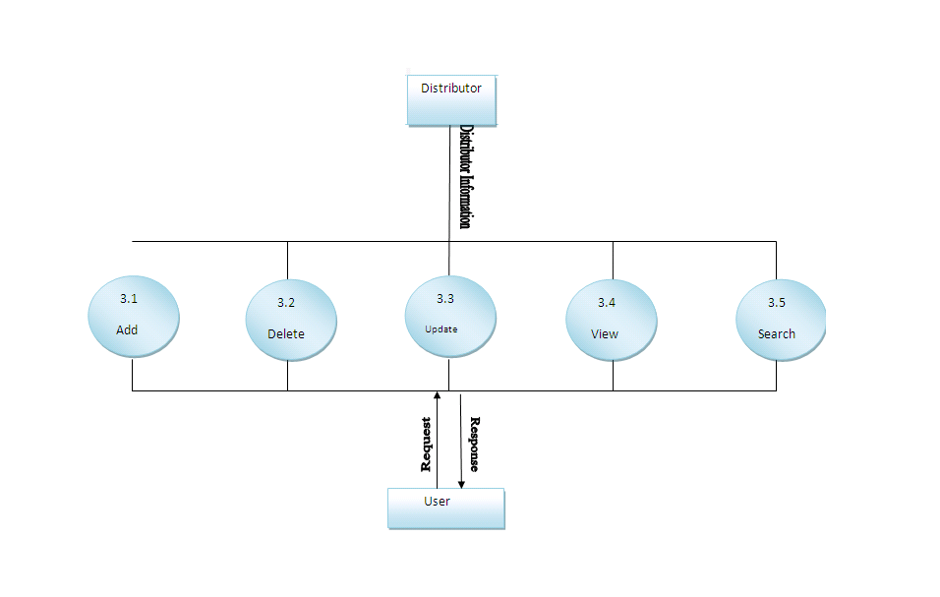

3.3. User Management
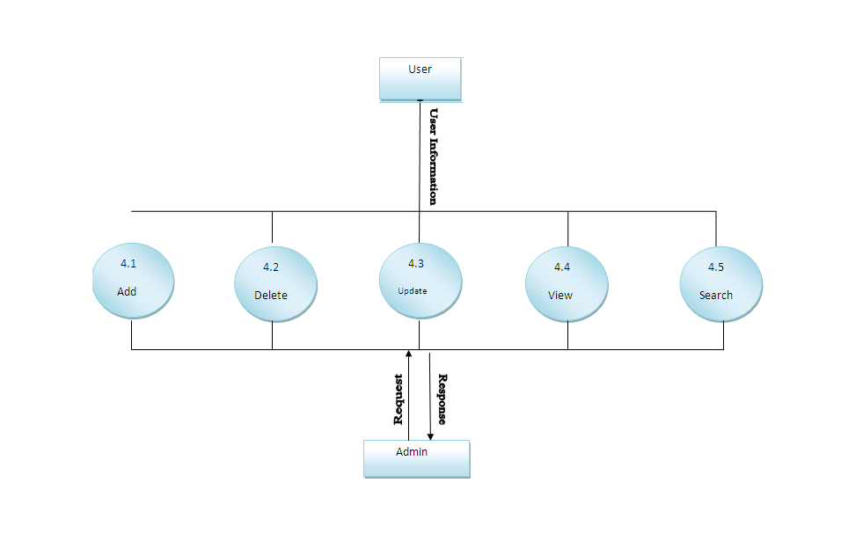

3.4. Record Management
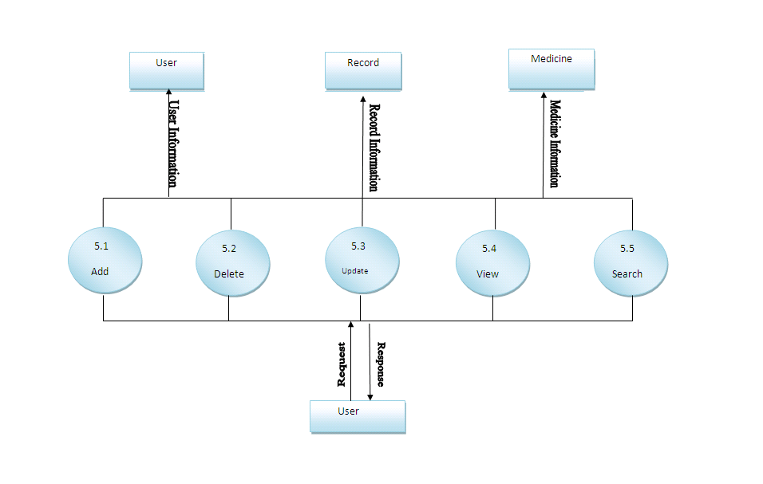

Name of the Students  (code on eProject Guide) | Nguyen Van Chien(1882) (Leader)  Tran Van Hien (1024)
Name of the Center | FPT Aptech
Name of the Project | Medical Store Billing System
Project Start Date/ End Date | 22-Aug-2009/ 22-Sep-2009
Form | Flow Chart
Form code | Form No.5/FC/Ver 1.0

Flow Chart

1. Login

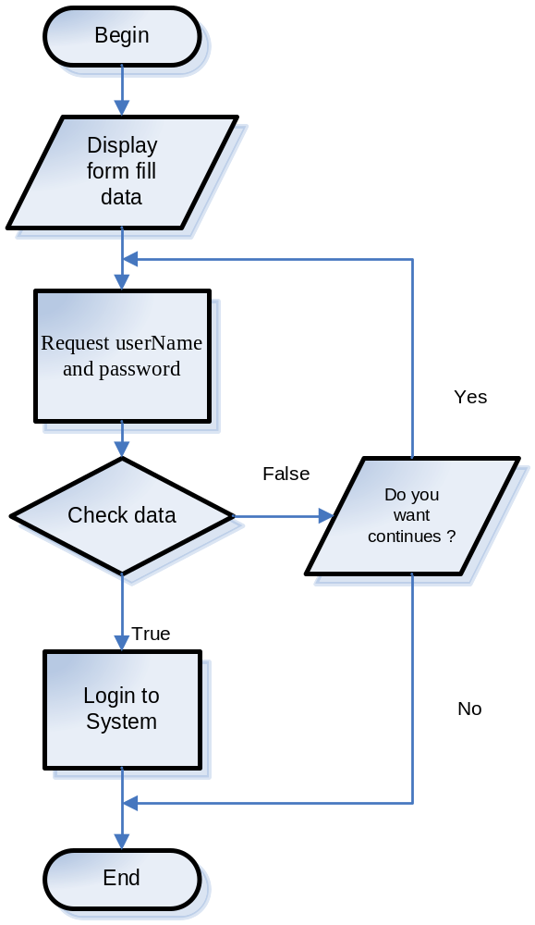

2. Add Records

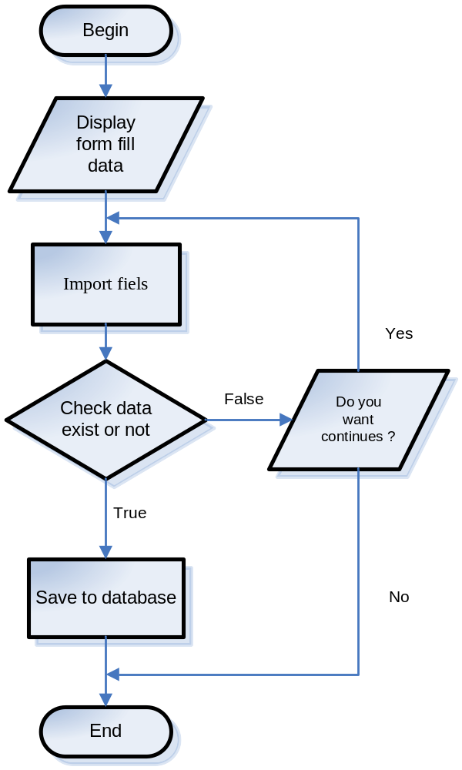

3. Update Records

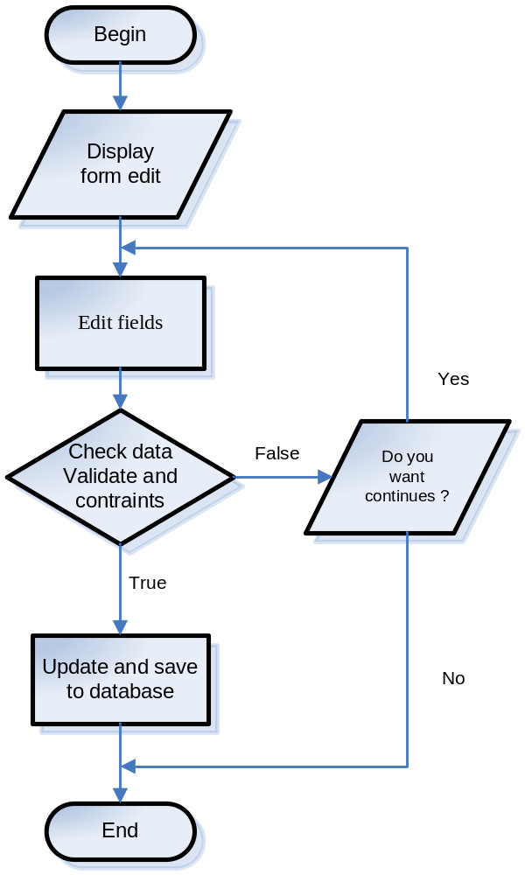

4. Delete Records

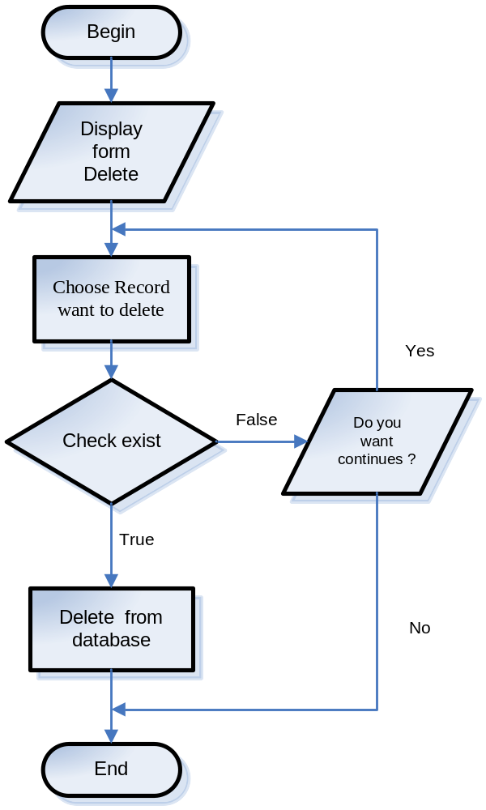

5. Search and View Records

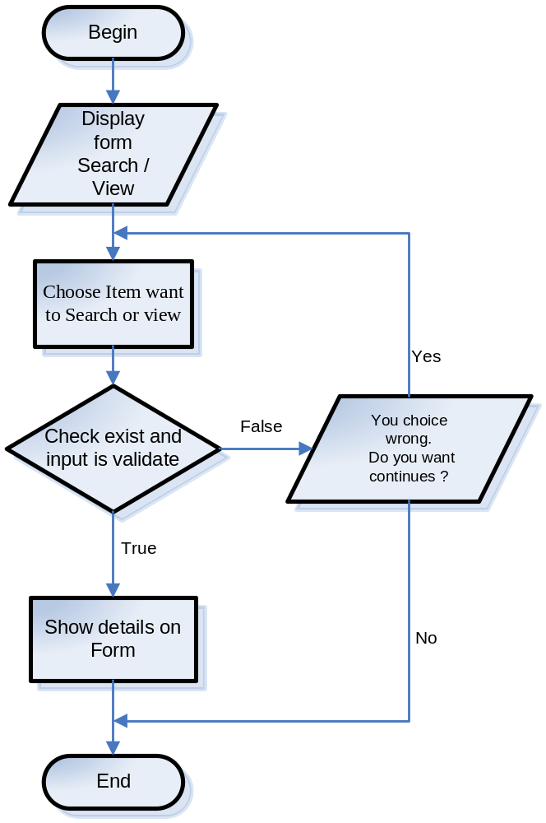

Name of the Students  (code on eProject Guide) | Nguyen Van Chien(1882) (Leader)  Tran Van Hien (1024)
Name of the Center | FPT Aptech
Name of the Project | Medical Store Billing System
Project Start Date/ End Date | 22-Aug-2009/ 22-Sep-2009
Form | Entity Relationship Diagram
Form code | Form No.6/ERD/Ver 1.0

1. Relationship Diagram

`
Medicine
- medicineCode
- medicineName
- medicineType
- measure

Measure

- Measure
N
M
N
1
User

userCode
userName
userType
password
userFullname
Orders

orderCode
customerCode
dateOrder
addressToDeliveuseCode

Customer

customerCode
customerType
customerName
customerAddress
customerPhone
customerEmail
M
N
N
1
N
1
M
N
payedReport

payedReportCode
billCode
datePay
payedMoney
1
N
Supplier

supplieCode
supplierName
supplierAddress
supplierPhone
M
billCode
billType
userCode
customerCode
addressToDeliver
dateStart
expiredTime
tax
price
status
Bill
1
N
1
N
N
medicineType

medicineType

2. Entity Relationship Diagram

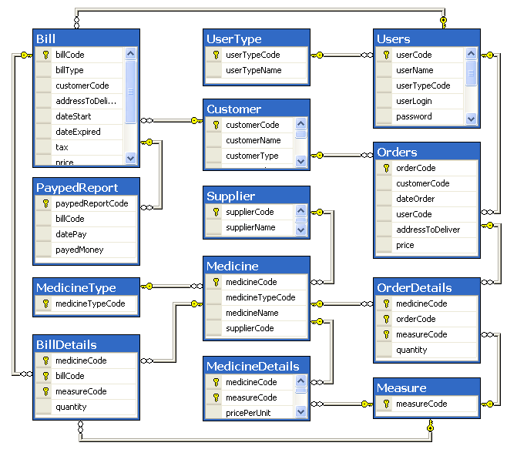

Name of the Students  (code on eProject Guide) | Nguyen Van Chien(1882) (Leader)  Tran Van Hien (1024)
Name of the Center | FPT Aptech
Name of the Project | Medical Store Billing System
Project Start Date/ End Date | 2-Sep-2009/ 12-Sep-2009
Form | Table Design
Form code | Form No.7/ERD/Ver 1.0

medicineType
Field name | Data type | Constraint | Description
mediniceTypeCode  medicineType | Varchar(10) | Primary key | Types of medicine: addictiveDrug (people can’t stop use it), poison, normalDrug (used in normal injury)

measure
Field name | Data type | Constraint | Description
MeasureCode  Measure | int  Varchar(10) | Primary key | The way to count drug: pack, tablet, bottle

Supplier
Field name | Data type | Constraint | Description
supplierCode | Int | Primary key, Identity (1, 1) | Code of each supplier
supplierName | Varchar(20) |  | Name of supplier
fullName | Varchar(100) |  | Full name of supplier
supplierAddress | Varchar(100) |  | Address of supplier
supplierPhone | Varchar() |  | Phone of supplier
supplierFax | Varchar() |  | Fax of supplier
supplierEmail | Varchar() |  | Email of supplier
supplierWebsite | Varchar() |  | Website of supplier

medicine
Field name | Data type | Constraint | Description
medicineCode | Int | Primary key, Identity (1, 1) | Code of each medicine
medicineName | Varchar(20) |  | Name of medicine
medicineTypeCode | int | Foreign key references medicineType(medicineType) | Type of medicine

Medinice Details
Field name | Data type | Constraint | Description
medicineCode | Int | Primary key Foreign key references medicine(medicineCode) | Code of each medicine
MeasureCode | int | Primary key | The way to count drug: pack, package, bottle
avaiableAmount | Int |  | Number of drugs into store
pricePerUnit | Float |  | Price of each drug used to create bill
Extra | Float |  | X% using when sell a drug  Price when sell = price per unit * (1 + extra/100)
registerNumber | Varchar(50)
Origin | Varchar(30)
used | Varchar(100)
termsOfUse | datetime
userGuide | Varchar(100)

Customer
Field name | Data type | Constraint | Description
customerCode | Int | Primary key, Identity (1, 1) | Code of each guest
customerType | Varchar(30) |  | Types of each guest: distributor, dealer, customer
customerName | Varchar(100) |  | Name of each guest
customerAddress | Varchar(100) |  | Address of each guest
customerPhone | Varchar(15) |  | Phone number of each guest
customerEmail | Varchar(100) |  | Email of each guest
customerFax | Varchar(15)
customerRelationship | Varchar(20)

Bills
Field name | Data type | Constraint | Description
billCode | Int | Primary key, Identity (1, 1) | Code of each bill
billType | Varchar(10) |  | Types of bill: import, export
guestCode | Varchar(10) | Foreign key references guest(guestCode) | Code of guest
addressToDeliver | Varchar(50) |  | If billType is “export”, it’s address to deliver
dateStart | Datetime |  | When create the bill
expiredTime | Datetime |  | When you can’t pay that bill
Price | Float |  | Total price of bill
Status | Varchar(10) |  | How a bill is process: not start, ongoing, completed
Tax | Float |  | Tax

Bill Details
Field name | Data type | Constraint | Description
medicineCode | int | Primary key  Foreign key references medicine(medicineCode) | Code of each medicine
billCode | Varchar(10) | Primary key  Foreign key references bill(billCode) | Code if each bill
Quantity | Int |  | Quantity of each medicine when you create a bill
Measure | Varchar(10) | Primary key  Foreign key references measure(measure) | Way to count a drug

Orders
Field name | Data type | Constraint | Description
orderCode | Int | Primary key, Identity (1, 1) | Code of each order
guestCode | Varchar(10) | Foreign key references guest(guestCode) | Code of each guest
dateOrder | Datetime |  | When you create this order
addressToDeliver | Varchar(50) |  | Address to deliver

Order Details
Field name | Data type | Constraint | Description
medicineCode | Int | Primary key  Foreign key references medicine(medicineCode) | Code of each medicine
orderCode | Varchar(10) | Primary key  Foreign key references order(orderCode) | Code of each order
Quantity | Int |  | Quantity of each medicine when you create a bill
MeasureCode | int | Primary key  Foreign key references measure(measure) | Way to count a drug

payedReport
Field name | Data type | Constraint | Description
payedReportCode | Int | Primary key, Identity (1, 1) | Code of payed report
billCode | Varchar(10) | Foreign key references bill(billCode) | Code of each bill
datePay | Datetime |  | When you pay a bill
payedMoney | Float |  | Amount of money you payed

Users
Field name | Data type | Constraint | Description
userCode | Varchar(10) | Primary key | Code of each user. They use their code like username to login
userName | Varchar(30) |  | Name of each user
userType | Varchar(10) |  | Type of each user: manager, accountant, seller
Password | Varchar(20) |  | Password of each user. They use it to login

Name of the Students  (code on eProject Guide) | Nguyen Van Chien(1882) (Leader)  Tran Van Hien (1024)
Name of the Center | FPT Aptech
Name of the Project | Medical Store Billing System
Project Start Date/ End Date | 22-Aug-2009/ 22-Sep-2009
Form | GUI
Form code | Form No.8/GUI/Ver 1.0

Login:

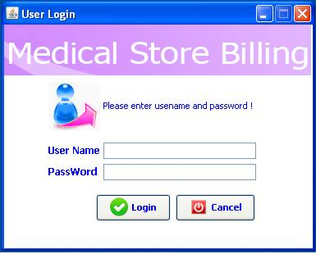

System Main :

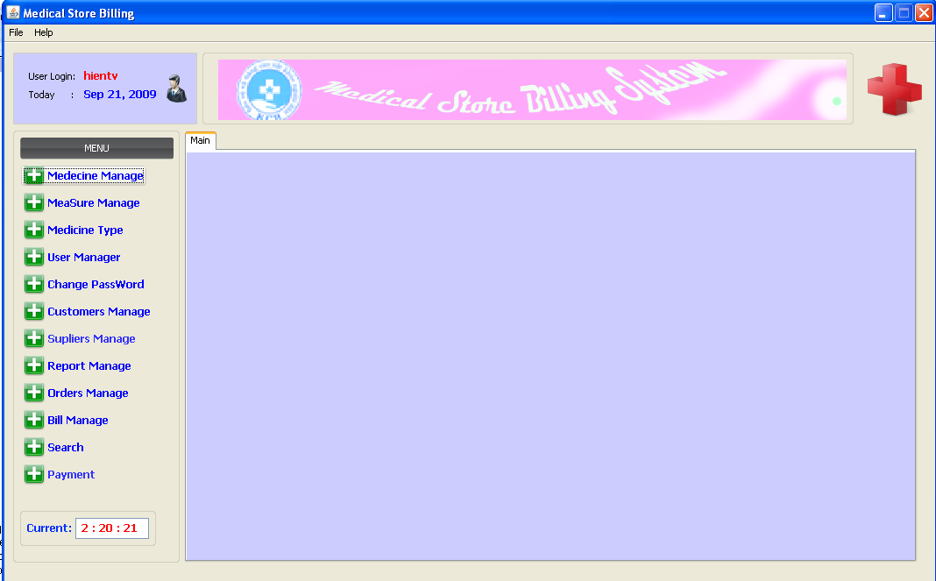

Medicine Manage :

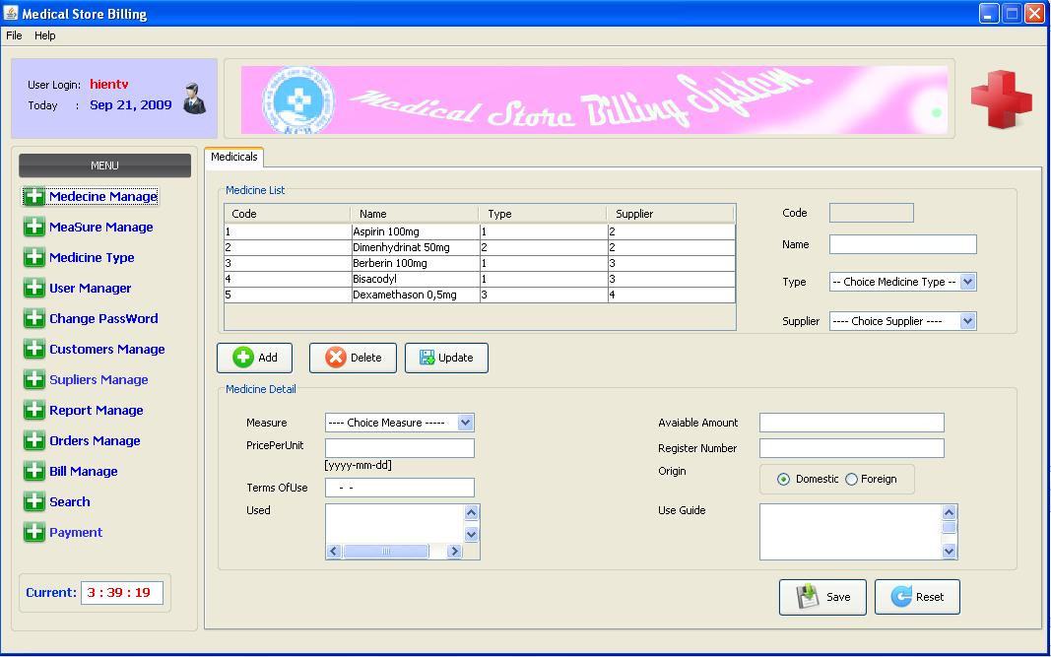

Measure Manage:

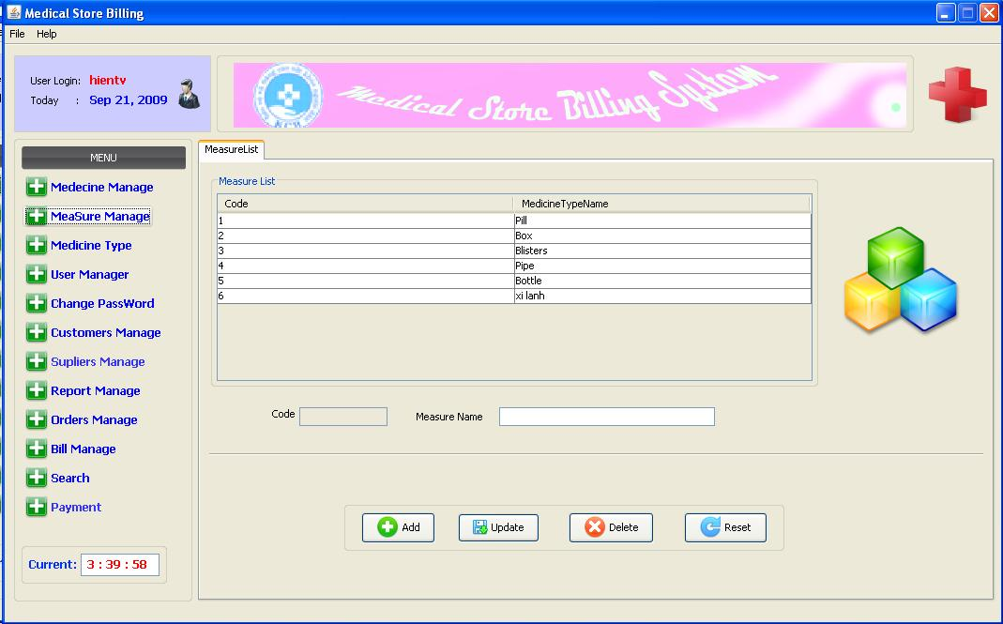

Medicine Type:

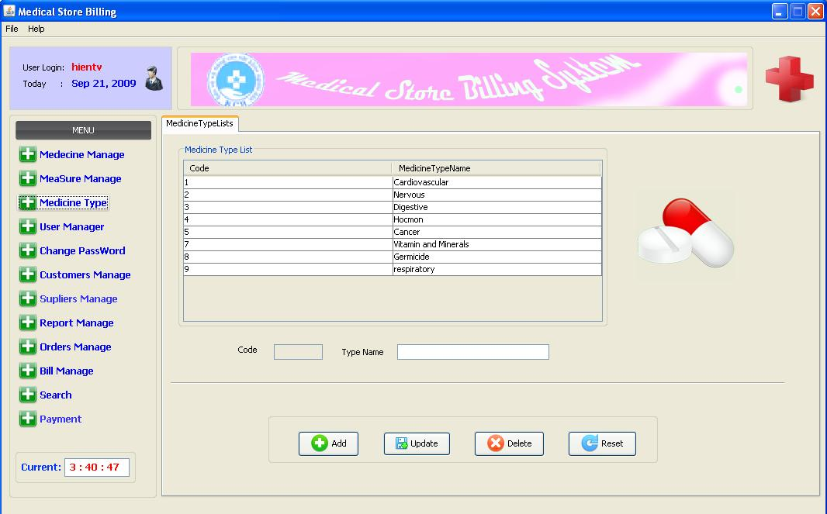

User Manage:

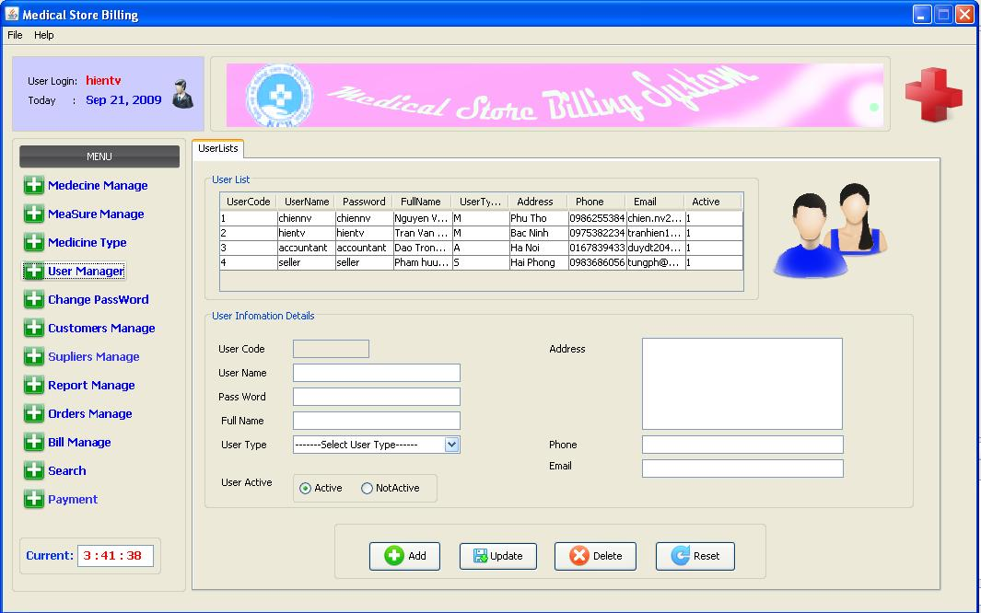

Change Password:

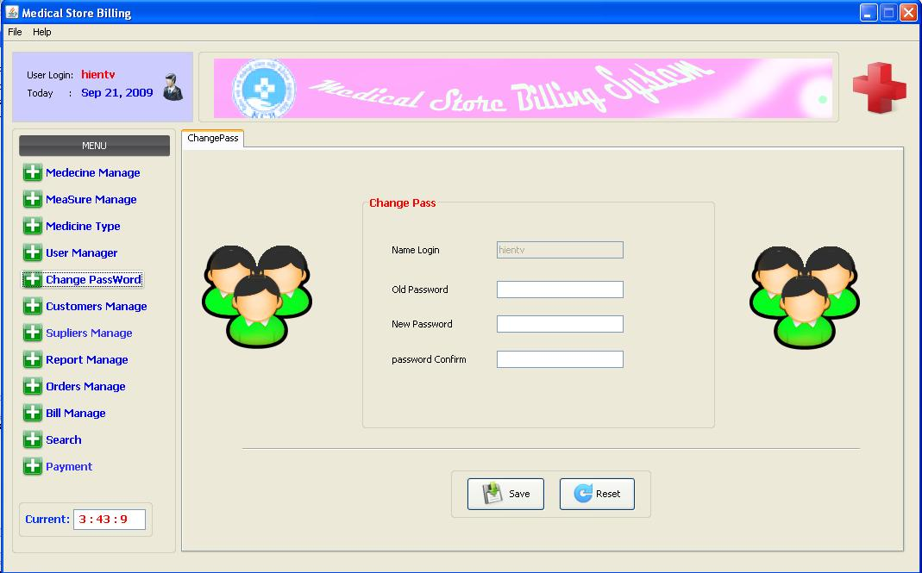

Customer Manage:

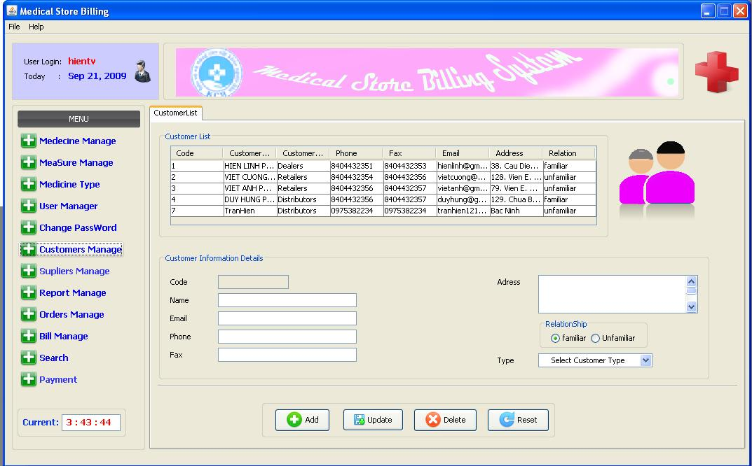

Supplier Manage:

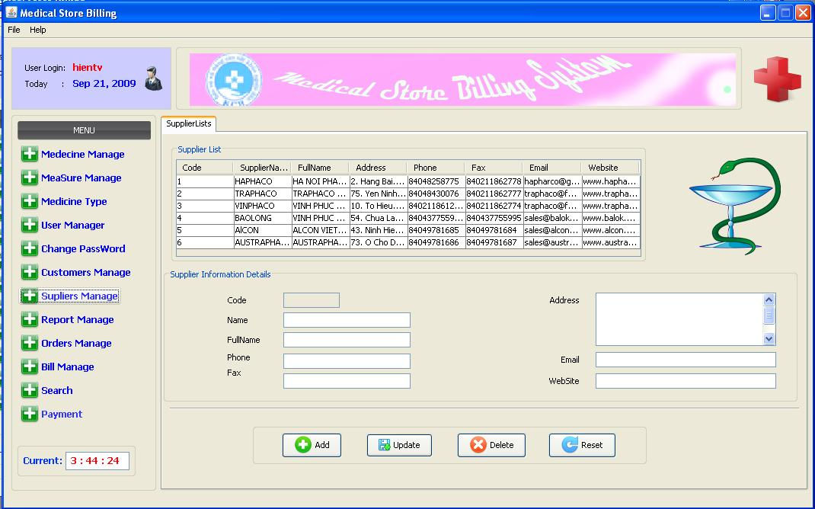

Report Manage:

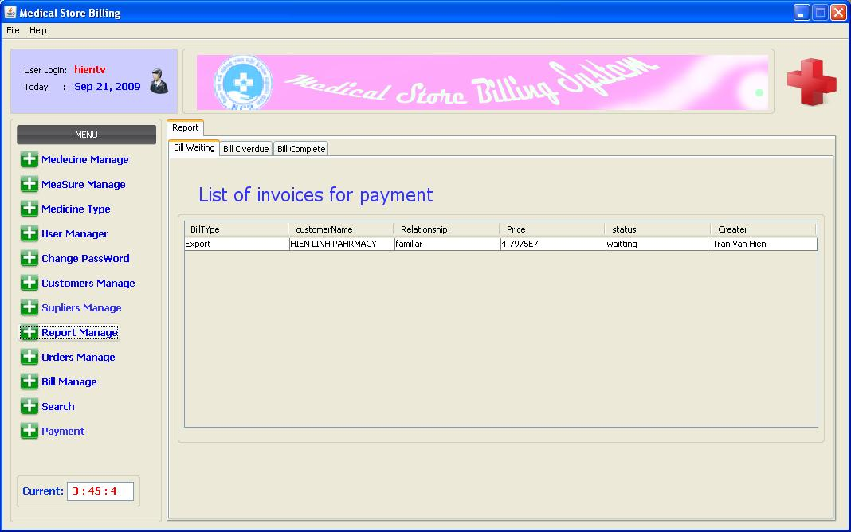

Order Manage:
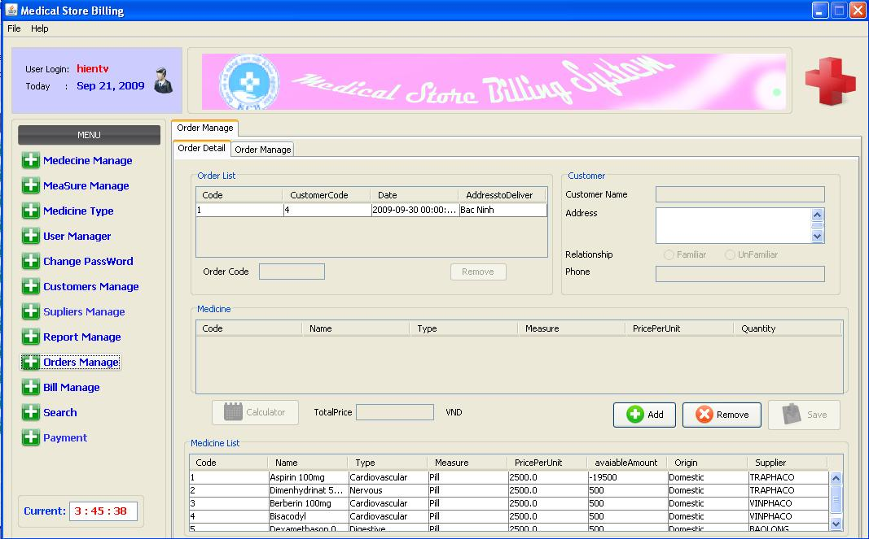

Bill Manage:

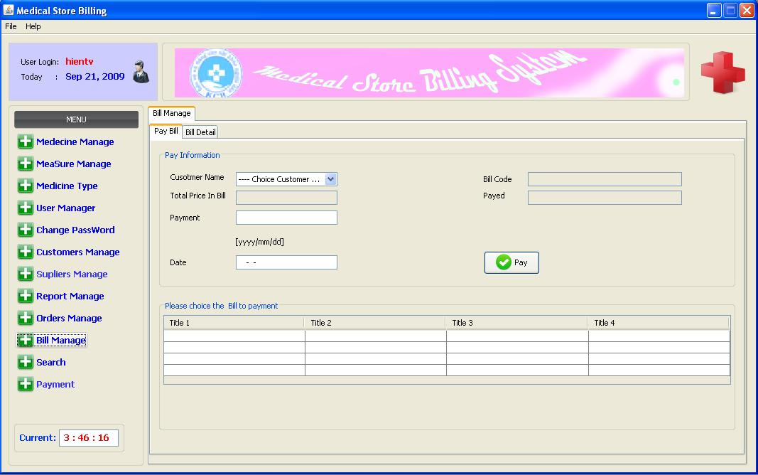

Search:

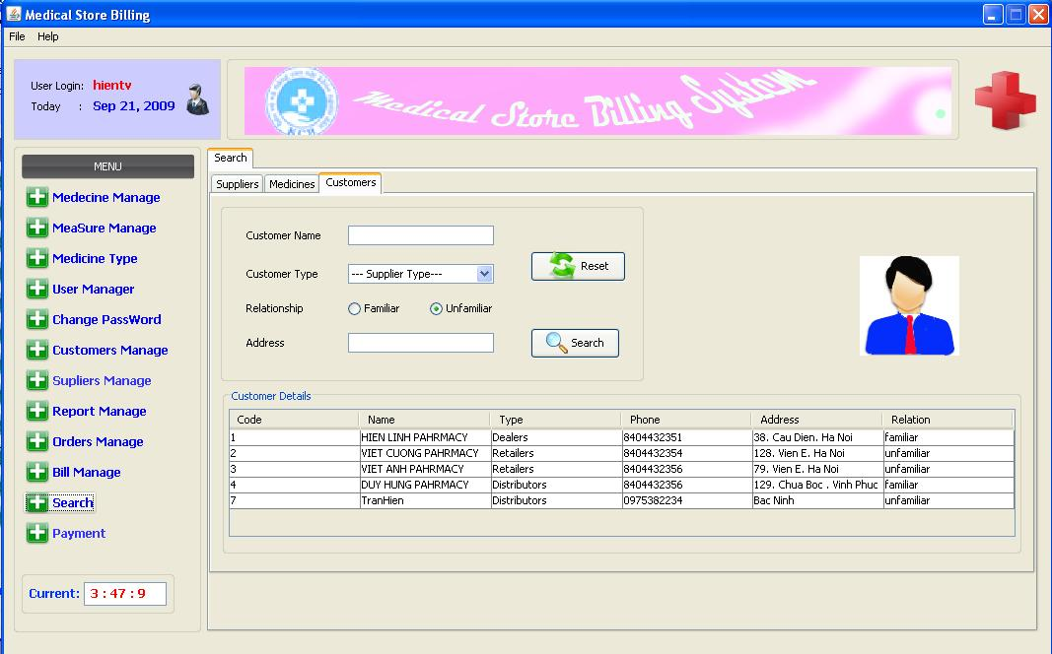

Payment:

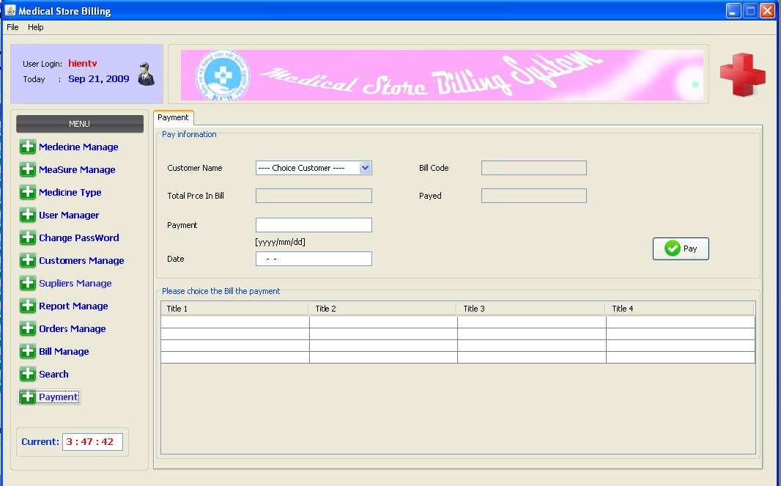

Name of the Students  (code on eProject Guide) | Nguyen Van Chien(1882) (Leader)  Tran Van Hien (1024)
Name of the Center | FPT Aptech
Name of the Project | Medical Store Billing System
Project Start Date/ End Date | 22-Aug-2009/ 22-Sep-2009
Form | Task sheet
Form code | Form No.9/TS/Ver 1.0

Project Ref. No.: |  | Project title | Activity plan prepared by | Date of preparation of activity plan
Sr.No. | Task | Project title | Activity plan prepared by | Actual start date | Actual days | Team member names | Status
1 | Write report | Status report v1 |  | 24/08/09 |  | Nguyen Van Chien,  Tran Van Hien | Completed
2 | Write report | Final status report |  | 29/08/09 |  | Nguyen Van Chien,  Tran Van Hien | Completed
3 | Application development | User management |  | 03/09/09 |  | Nguyen Van Chien,  Tran Van Hien | Completed
4 | Application development | Medicine management |  | 05/09/09 |  | Nguyen Van Chien,  Tran Van Hien | Completed
5 | Application development | Customer management |  | 08/09/09 |  | Nguyen Van Chien,  Tran Van Hien | Completed
6 | Application development | Supplier management |  | 10/09/09 |  | Nguyen Van Chien,  Tran Van Hien | Completed
7 | Application development | Order management |  | 13/09/09 |  | Nguyen Van Chien,  Tran Van Hien | Completed
8 | Application development | Bill management |  | 16/09/09 |  | Nguyen Van Chien,  Tran Van Hien | Completed
9 | Application development | Search |  | 17/09/09 |  | Nguyen Van Chien,  Tran Van Hien | Completed
10 | Application development | Report |  | 19/09/09 |  | Nguyen Van Chien,  Tran Van Hien | Completed
11 | Application development | Help |  | 21/09/09 |  | Nguyen Van Chien,  Tran Van Hien | Completed

